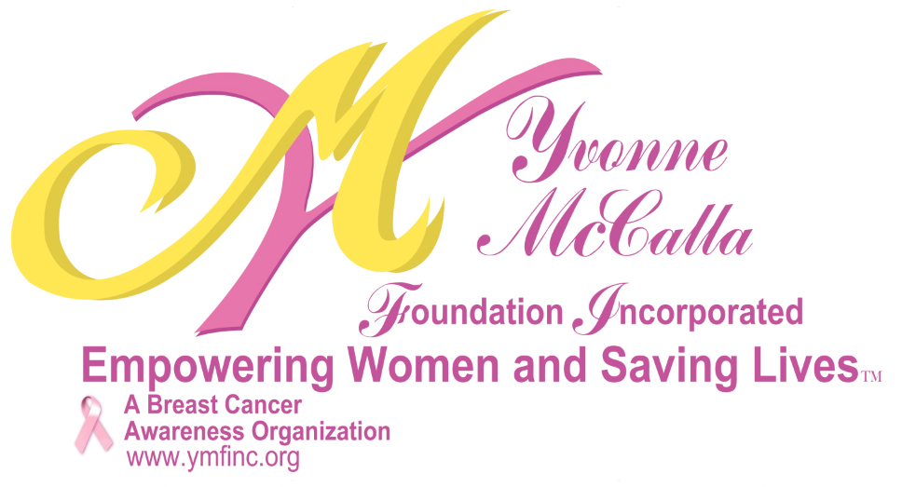
Yvonne McCalla Foundation, Inc.
Nursing Scholarship

Dear Applicant:

The Yvonne McCalla Foundation, Inc. is happy to announce that we are accepting applications for our Nursing Scholarships. We seek to award 2 individuals with scholarship monies worth $1500 each, to assist with their college education towards the field of Nursing.

Criteria for Application:

- Applicant must be a minority female.
- Applicant must be a High School Senior who will declare a major in Nursing or current college/university student pursuing a degree in Nursing.
- Submit (2) letters of recommendation from a teacher/professor and/or School Counselor/ Academic Advisor.
- Personal Essay about why you are pursuing a career in nursing and your educational goals (250 words minimum).
- Provide a copy of your current transcript reflecting a GPA of 3.0 or above in sealed envelope from your School Counseling/Registrar Office.
- Must be enrolled in an accredited School of Nursing by September.
- Recipients will be required to volunteer 20 hours of community service to YMF Inc. between June – December of the calendar year scholarship is awarded.

Complete applications must be postmarked no later than
April 15th and mailed to the address above.

Yvonne McCalla Foundation Inc.
701 Newark Ave Suite 108
Elizabeth, NJ 07208
1888-499-9015

Web: www.ymfinc.org
Email: ymfinc.org@gmail.com

Board of Directors

Debra N. Marshall
President

Desiraee Holt
Vice President

Debbie Brooks-Wynter
Treasurer

Vivian Arrindell

Celeste Pouncy

Advisory Board

Dr. Michelle Azu

Carl L. Marshall, Esq.

Mary Searight

Fatima A. Scipio

